**FINANCIAL INSTITUTION REGISTRATION**

1. **When we open the application, we can see the home page. There is a 'New Registration' button for new registrations. Click on the button.**

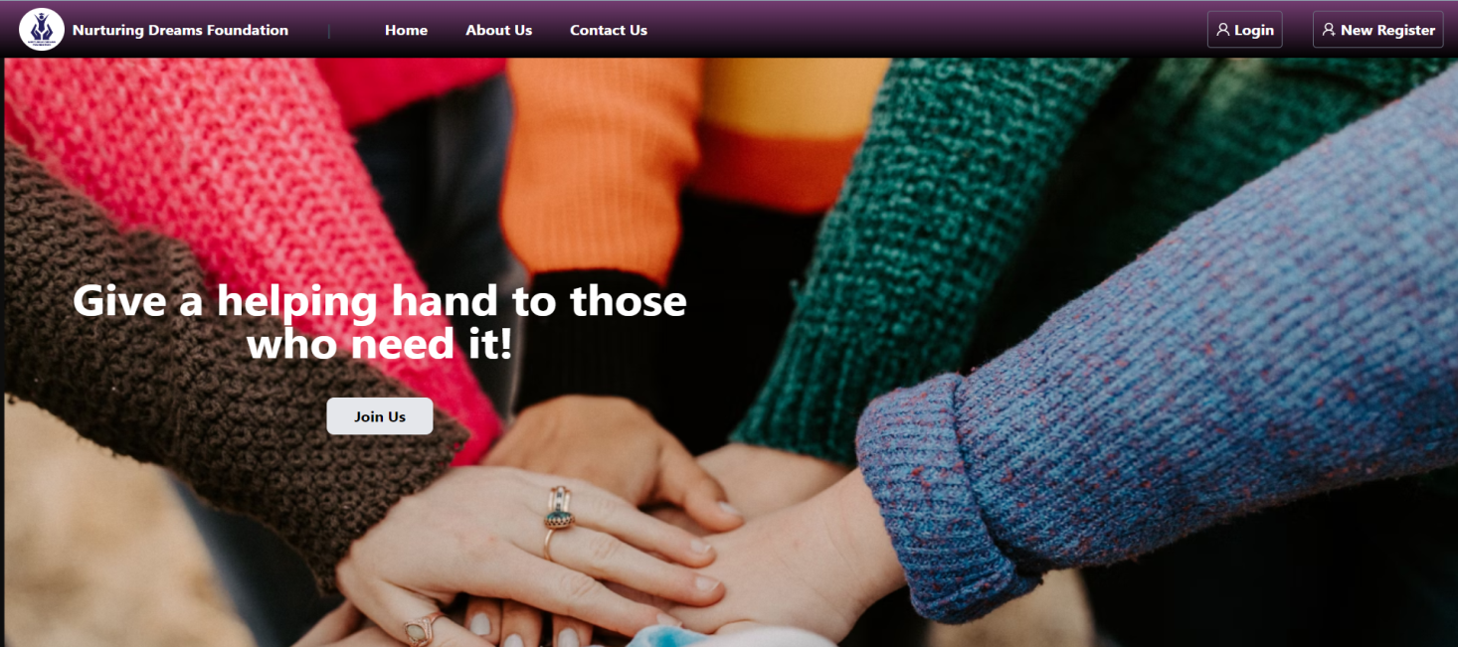

1. **After clicking, another window will open. Select 'Financial Inst' on this window.**

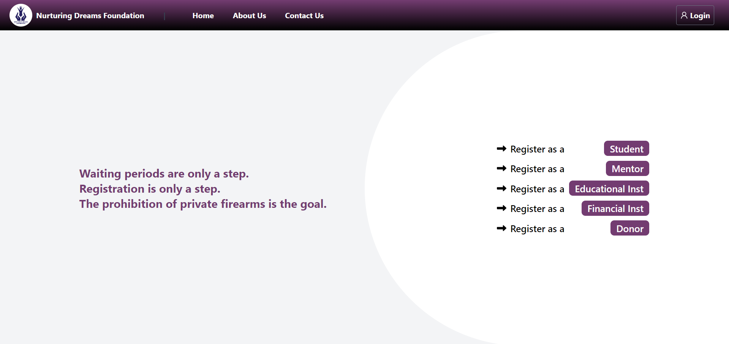

**3. All fields should be filled out as they are mandatory.**

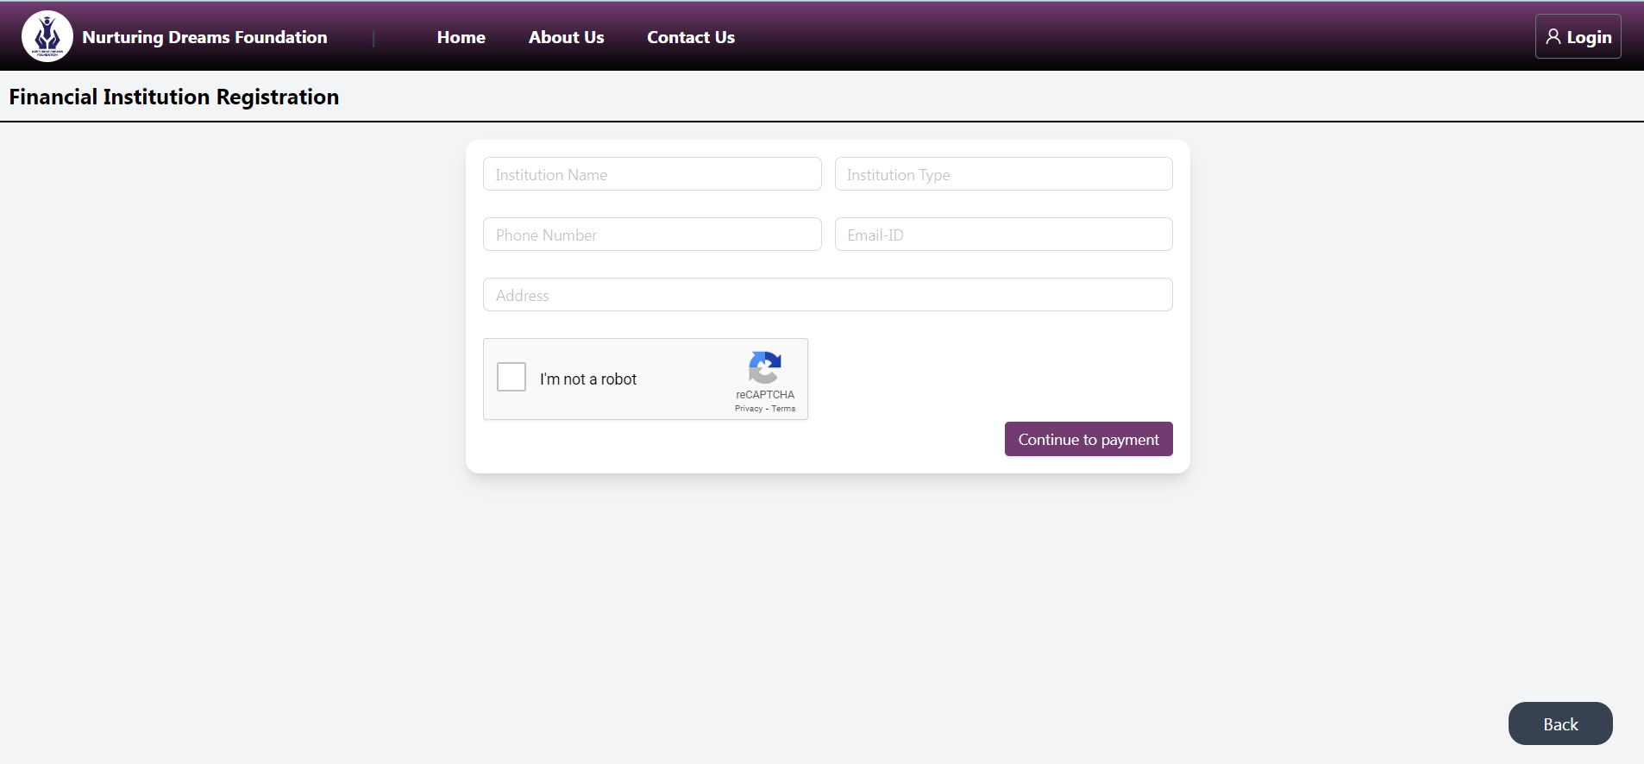

**4. This is a sample example. After filling out all the fields, press the 'Continue Payment' button.**

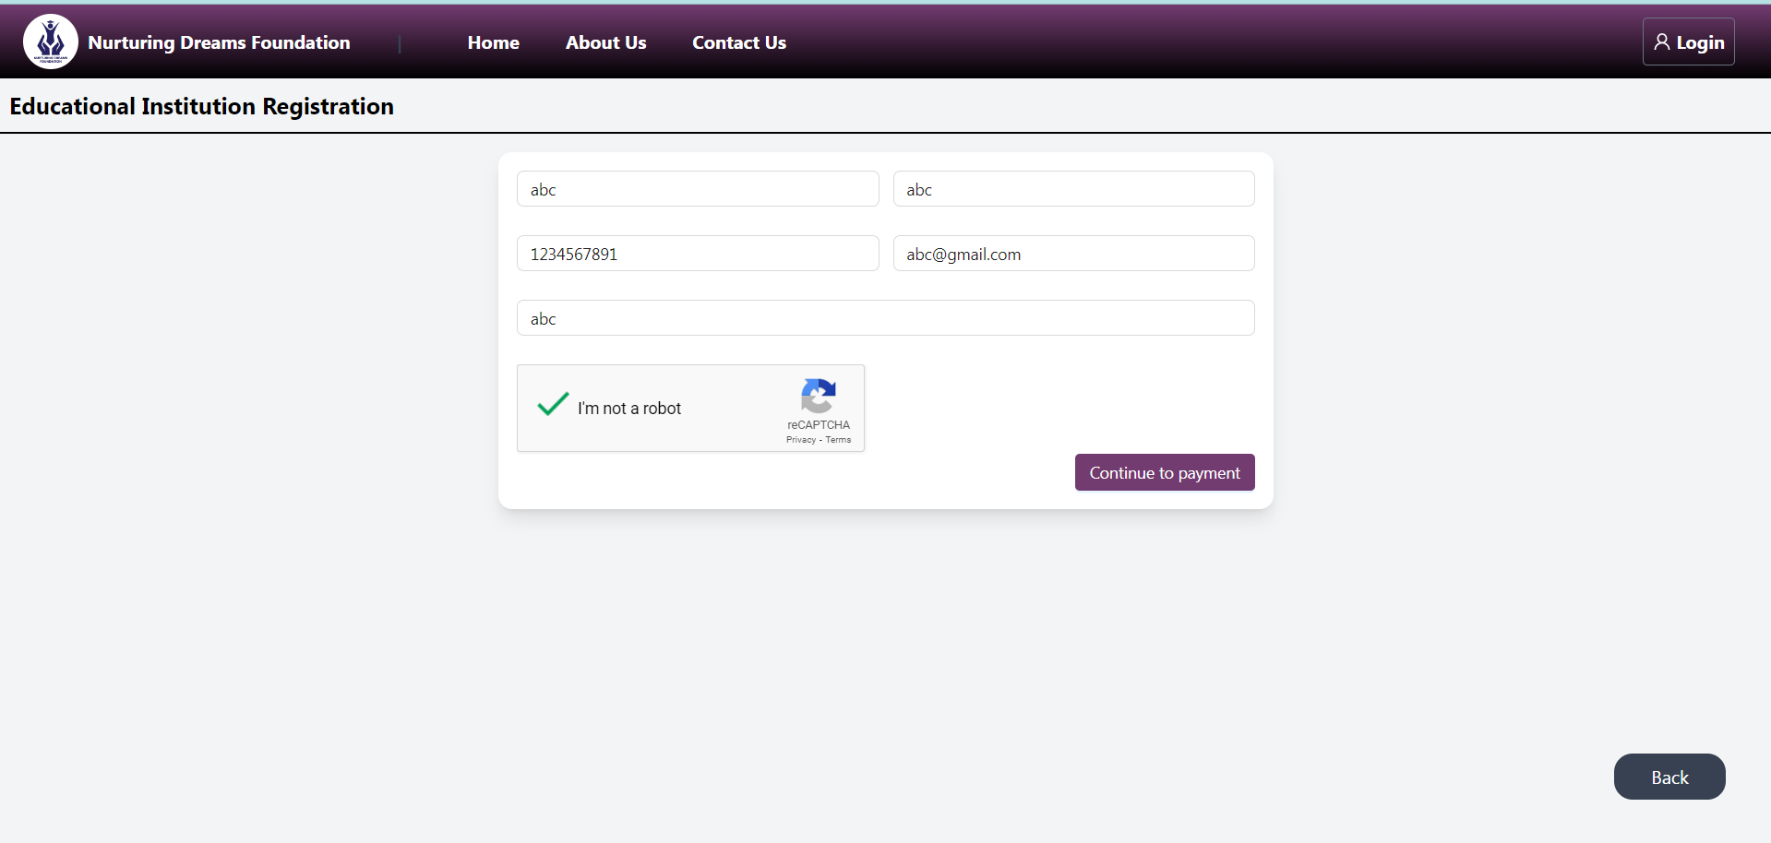

**5. Make the payment by clicking the 'Pay Now' option. Note: After a successful payment, you will complete your application process. If your payment is not successful, your application will not be complete. If the payment is unsuccessful, please continue from the beginning.**

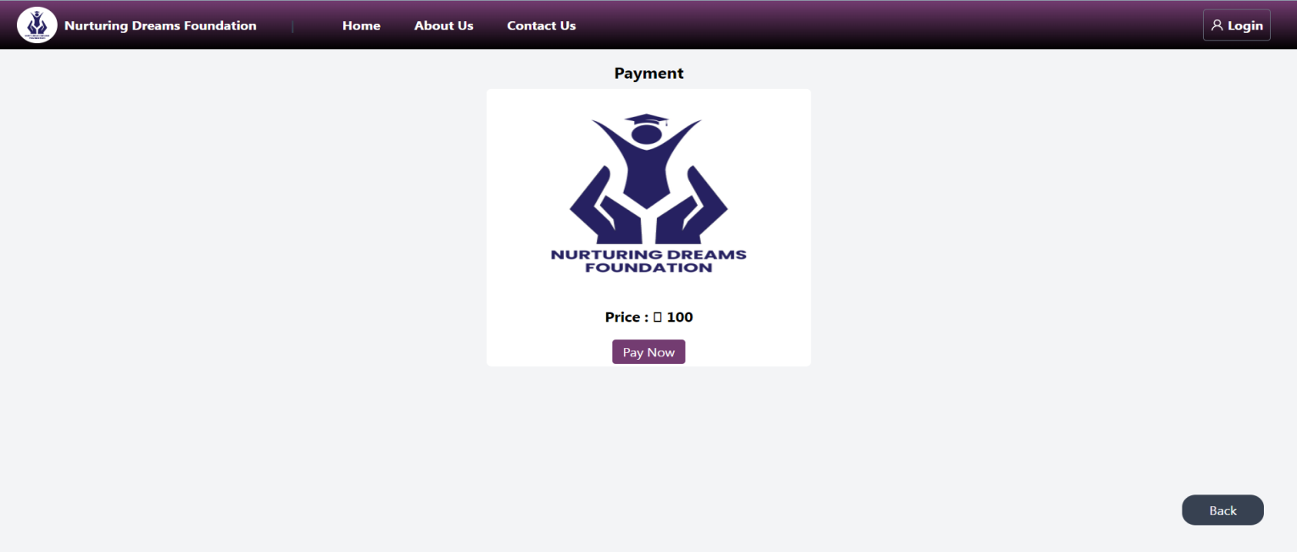

**6. This is the successful payment image.**

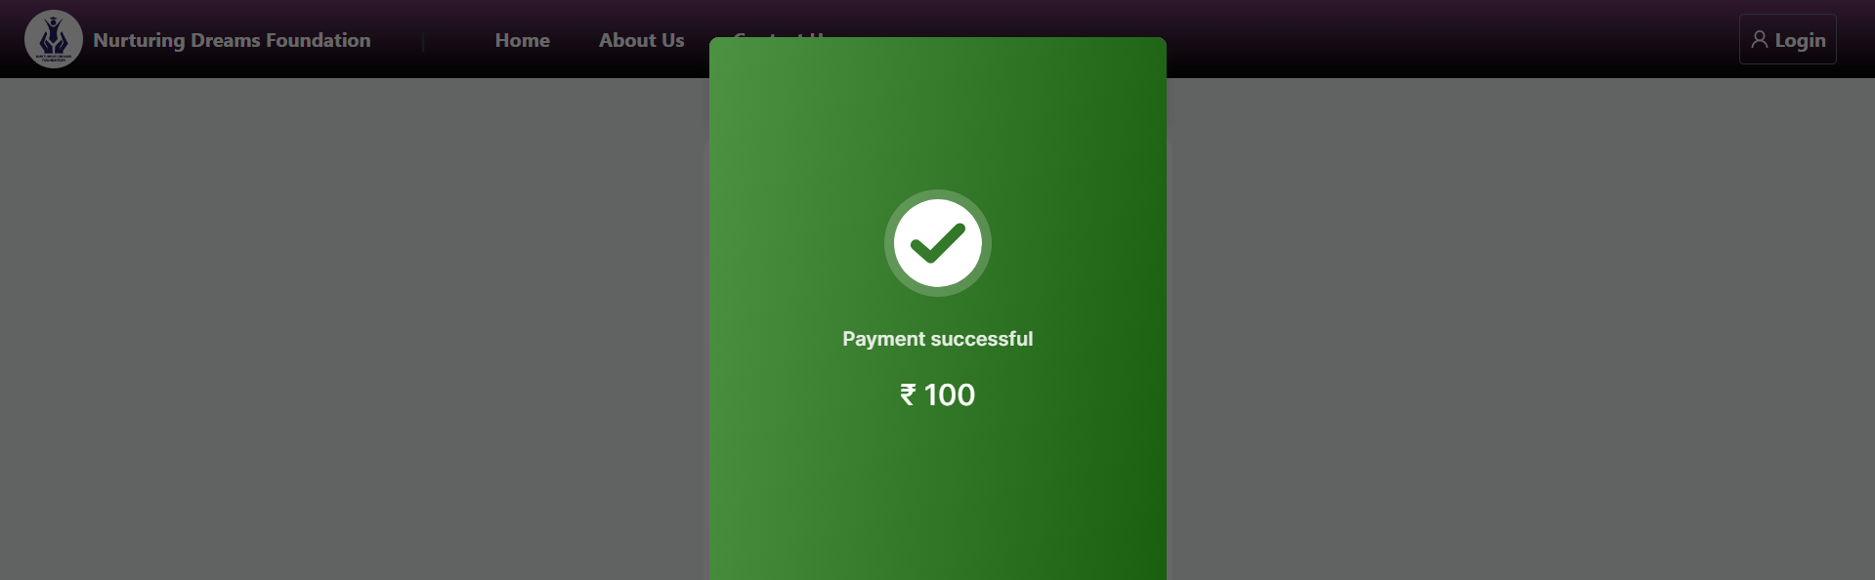

**7. After successful registration, you will see this type of window, and you will also receive a confirmation email.**

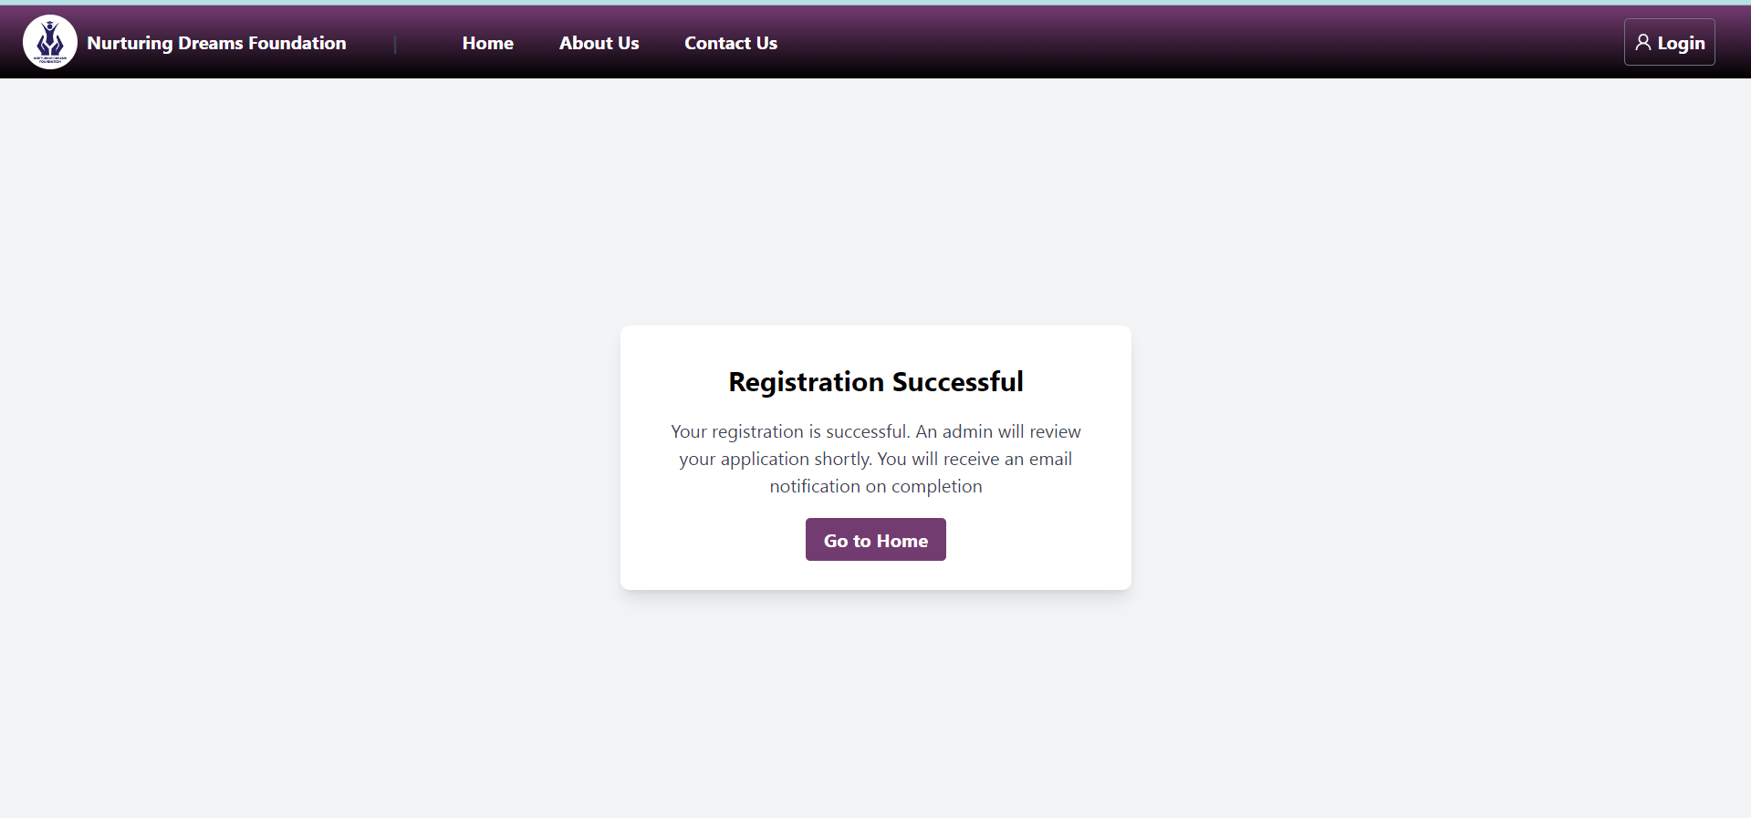

**8. This is a sample confirmation email.**

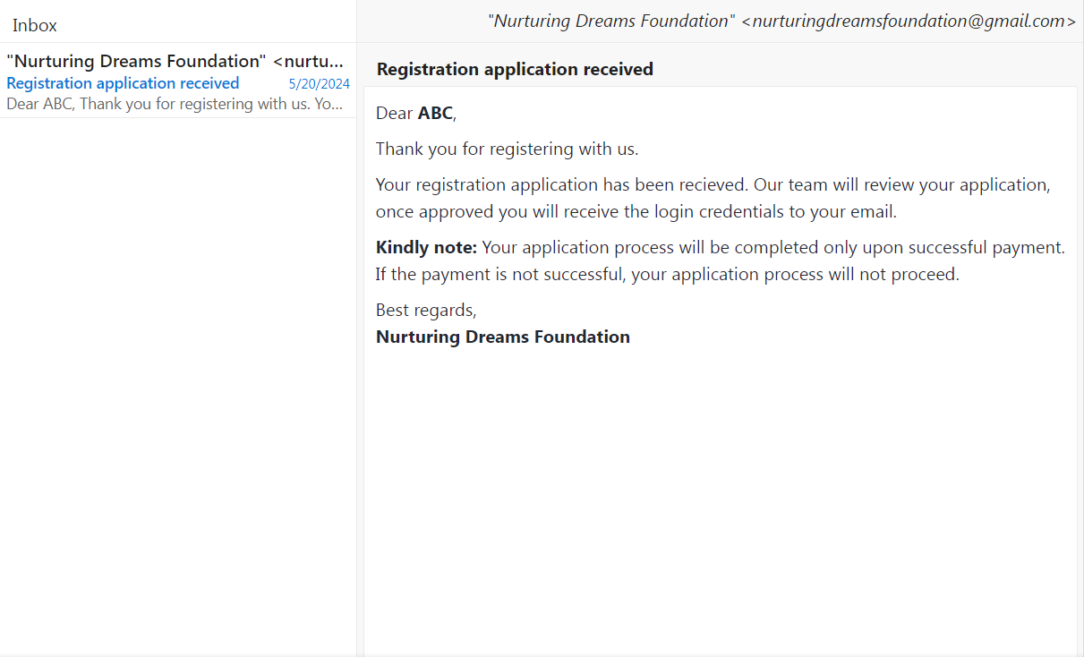

**9. If your application is rejected or put on hold, you will receive this type of email notification.**

**🡪 Reject**

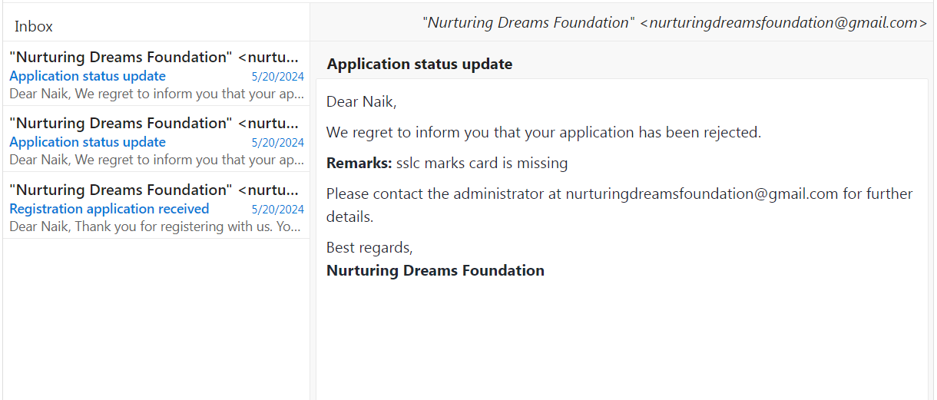

* **Hold**

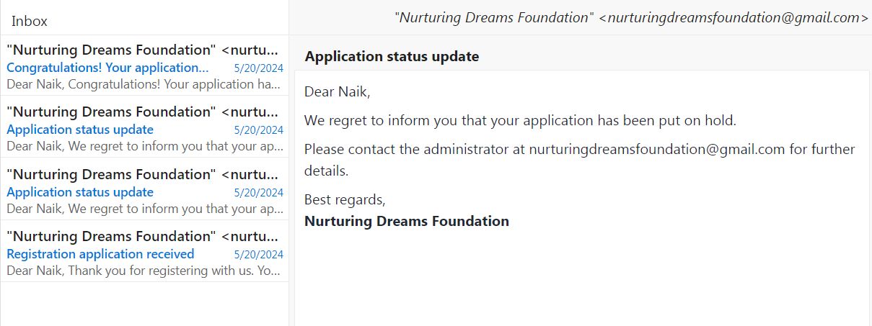

**10. If approved by the admin, you will receive login credentials via email. The below image is a sample email.**

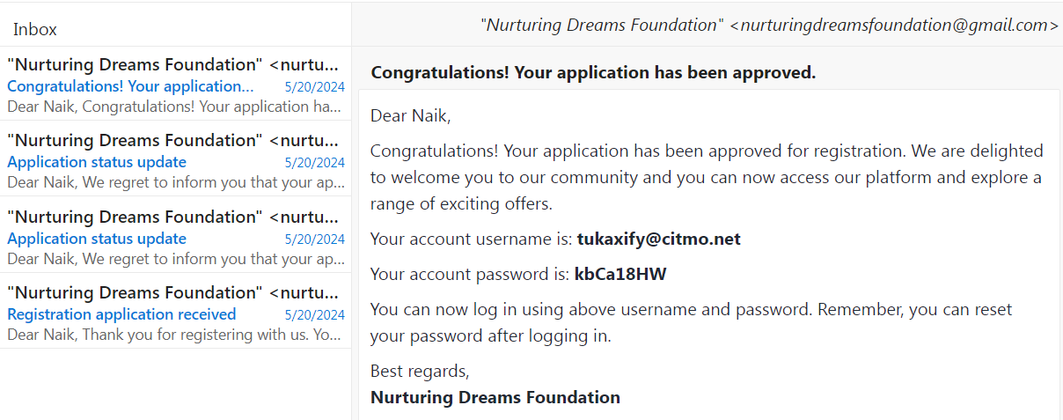

**11. Use the credentials to log in to the application.**

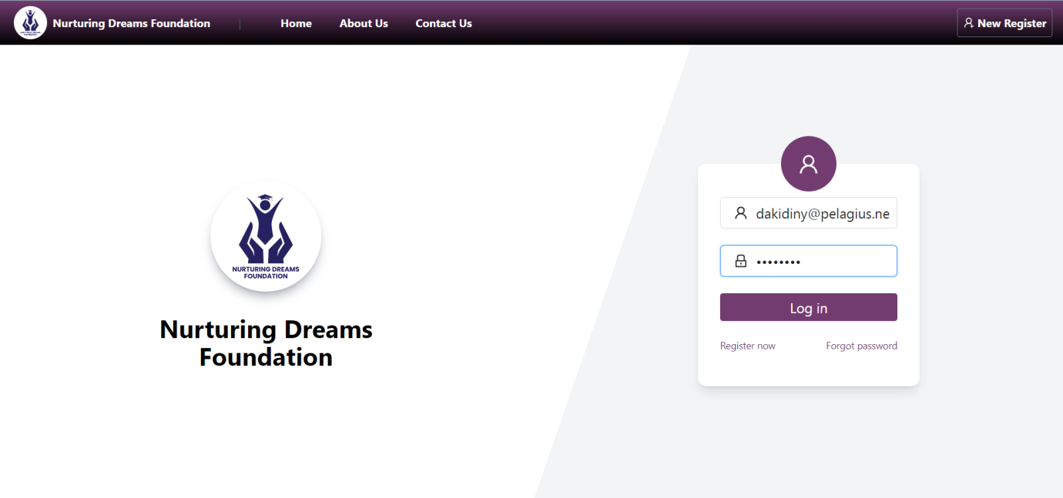

**12. This is the financial institution dashboard. Here, they can see the count of scholarship and loan applications.**

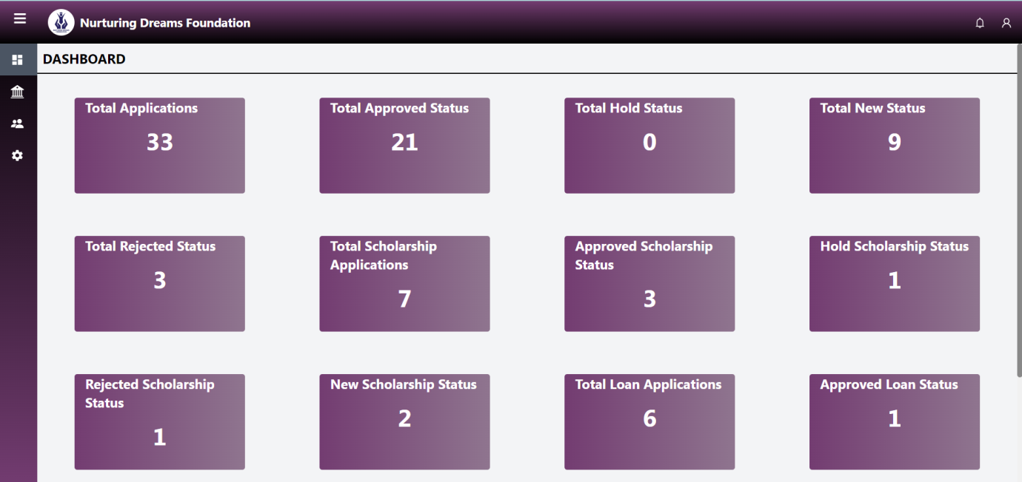

**13. Here, financial institutions can see the loan application status and information of applicants who applied for their loans.**

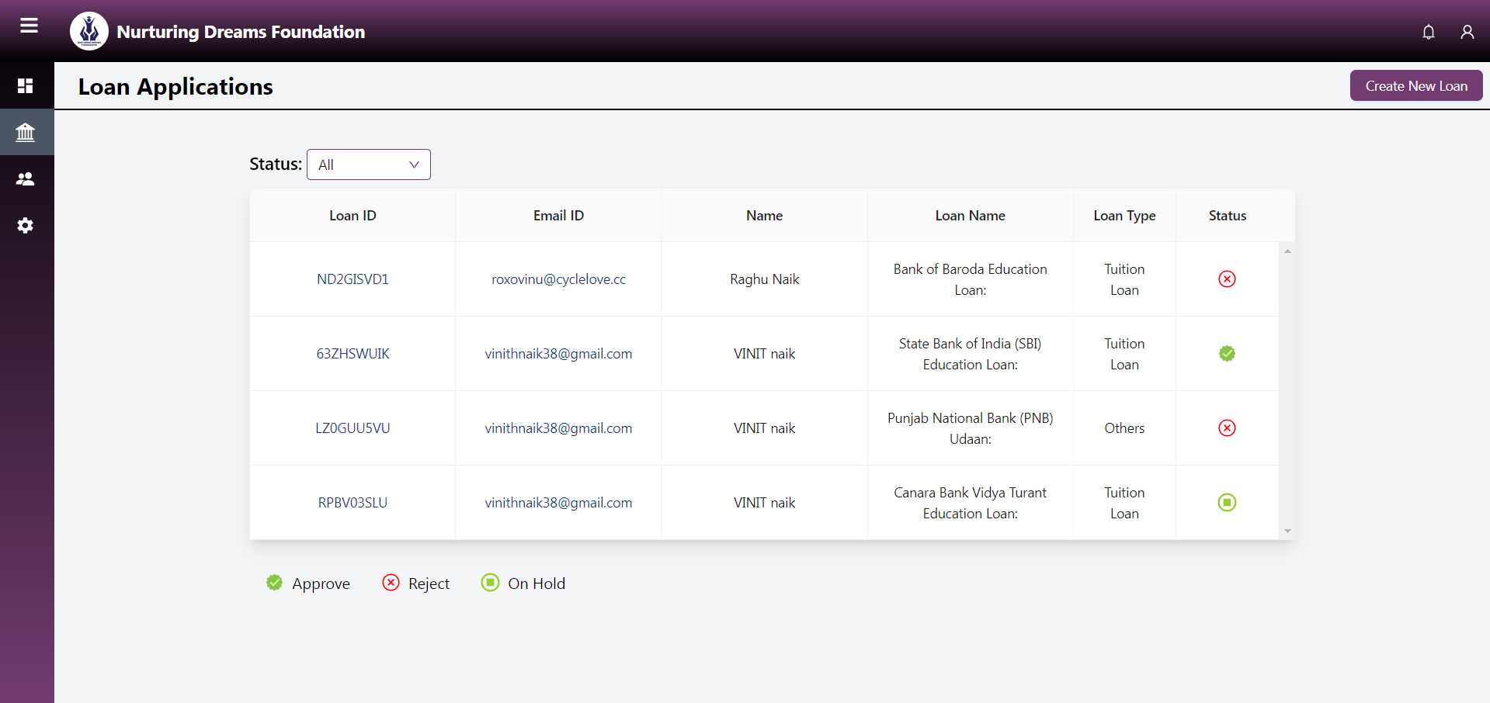

**14. Here, they can create a loan product by clicking the 'Create New Loan' button.**

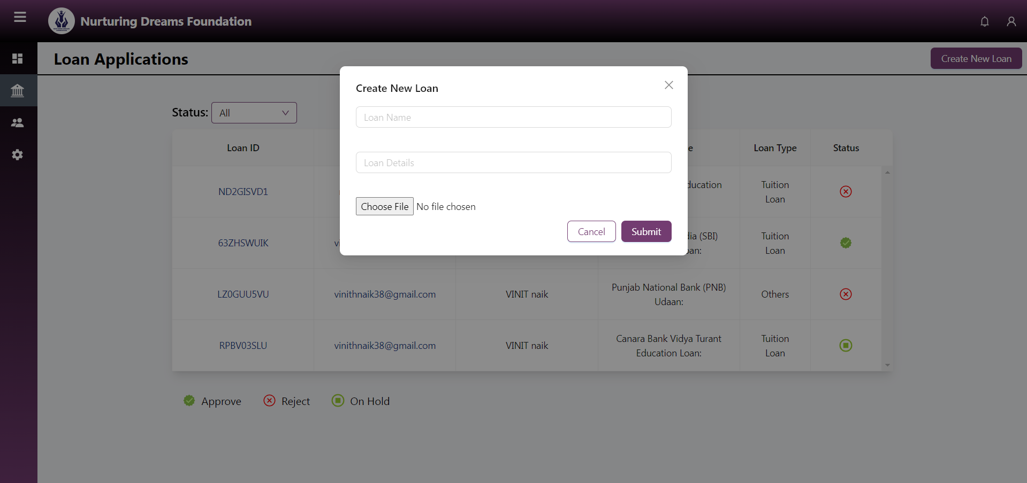

**15. Here, the loan name, loan details, and attachments must be submitted. After that, click 'Submit'.**

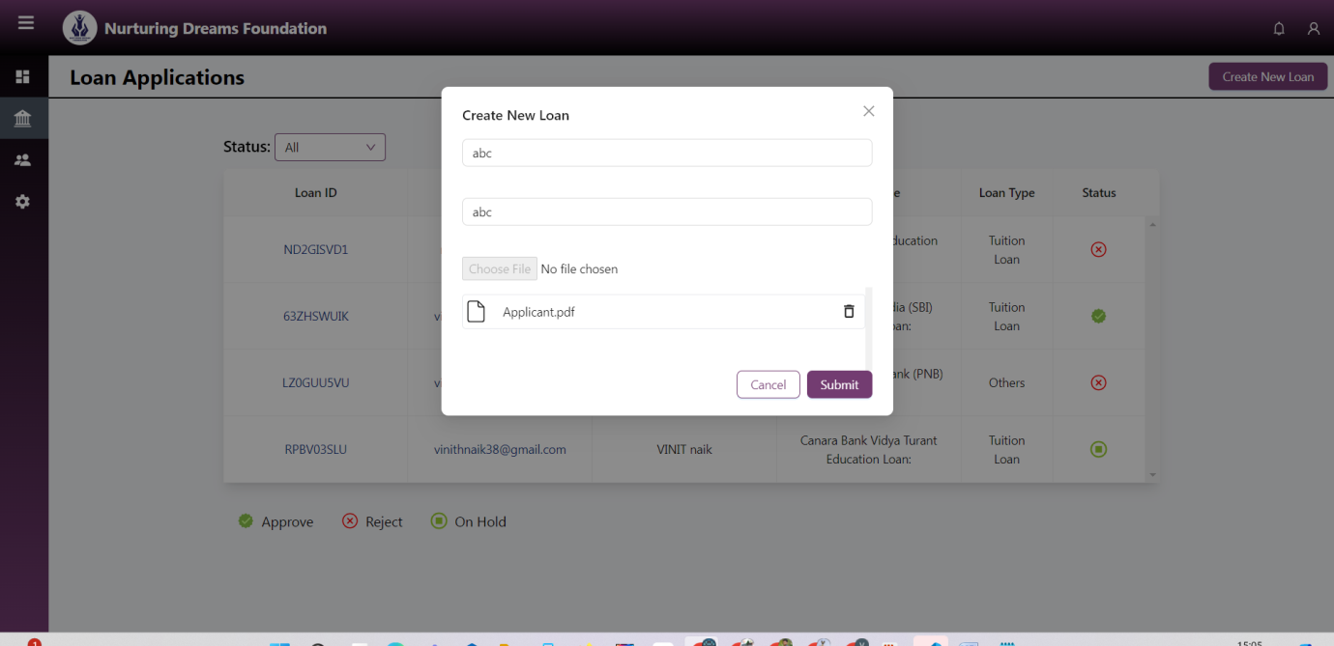

**16. Here, financial institutions can see all user information for those who have registered for this application.**

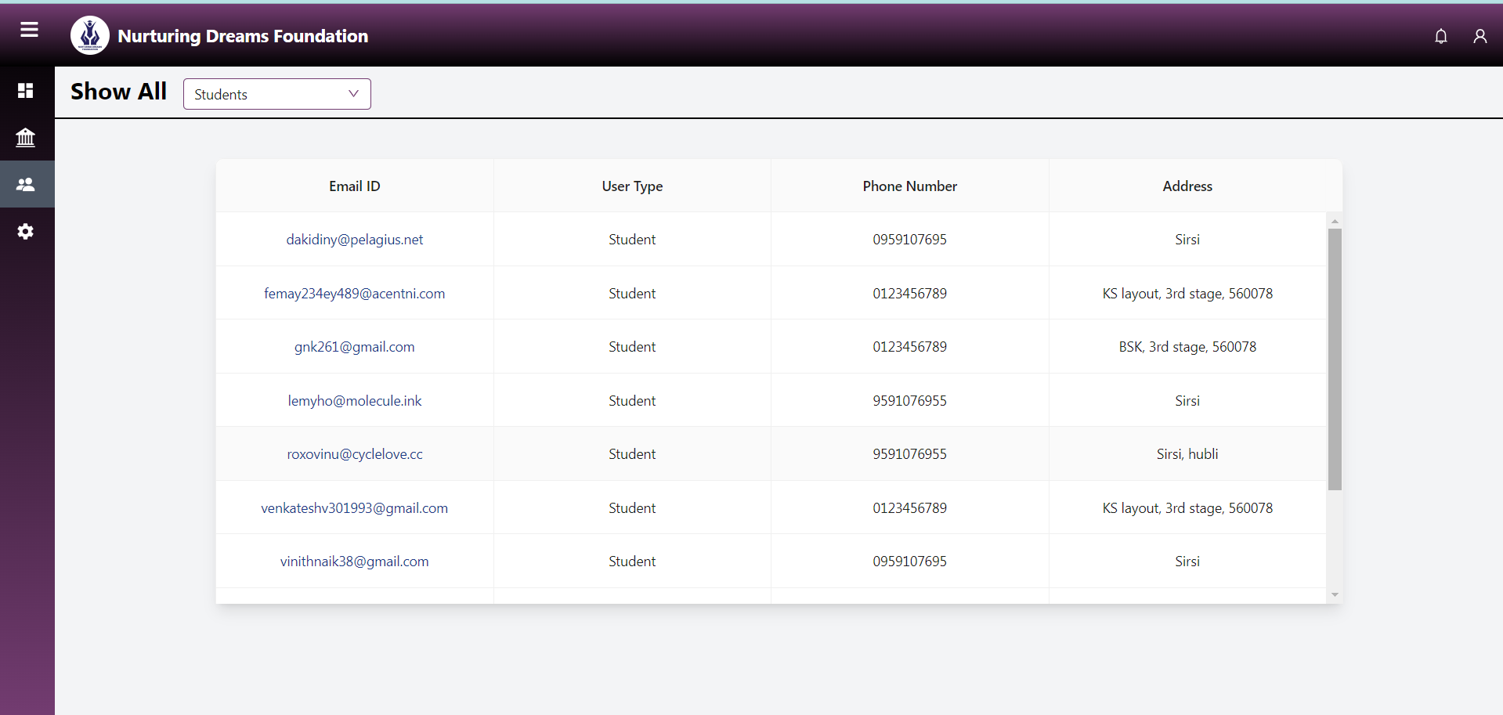

**17. Here you can reset your password and update your profile.**

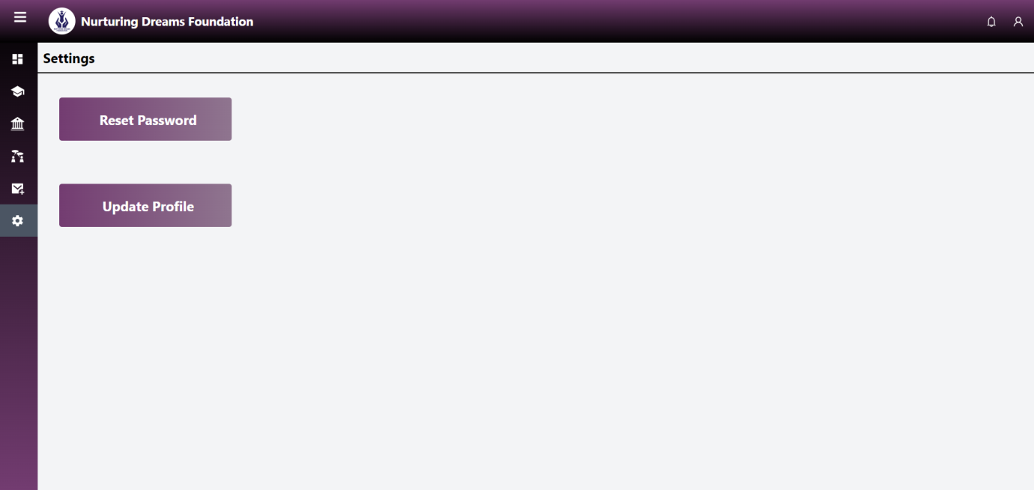

* **Reset password**

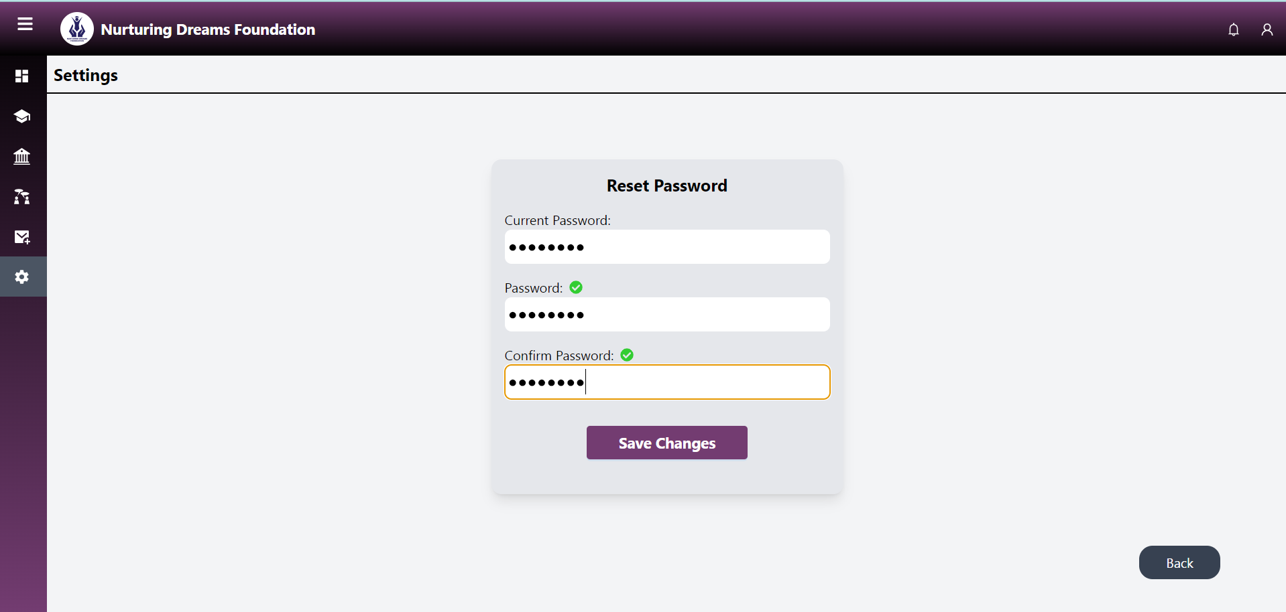

* **Profile update**

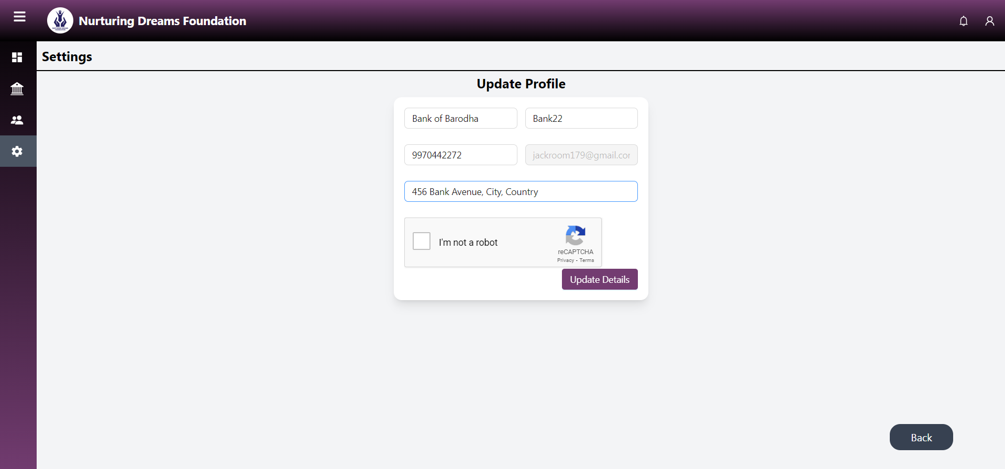

**18. After resetting and updating the profile, you will get an email notification of the confirmation.**

**🡪 Profile update**

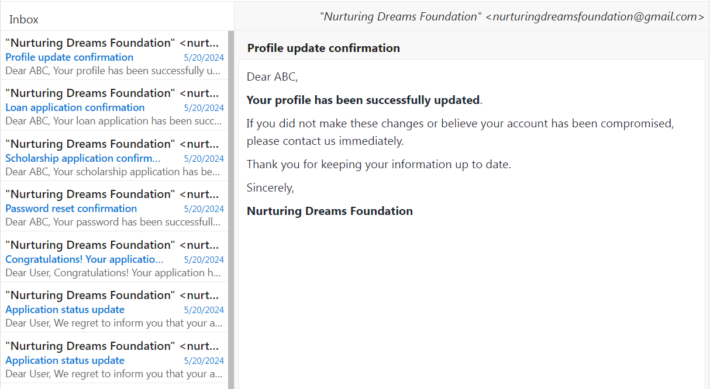

* **Reset password**

